# ICT & Infra S3 Supporting Services and Monitoring week 8

|  |  |
| --- | --- |
| Class: |  |
| Student number: |  |
| Student name: |  |

## Introduction

The purpose of this assignment is to make the student aware of different options for migrating different types of data to the cloud. Assignment 1 is theoretical while Assignment 2 is much more practical.

Assignment 3 is more related to resilience and failover.

### Assignment 1. Essay “Choosing the right cloud storage”

### Difficulty: ★★★☆☆.

1. The details are provided [here](http://portal.fontysict.nl/Studentenplein/LMC/2021nj/Infrastructure/S3-CB/Monitoring_SupportingServices/Assignment%20File_Data%20Migration%20Part%20I.docx?Web=1)

You can submit your document separately or paste the contents below

|  |
| --- |
| *Solution:* |

### Assignment 2. Migrating structured data to AWS

### Difficulty: ★★★★☆.

1. The details are provided [here](http://portal.fontysict.nl/Studentenplein/LMC/2021nj/Infrastructure/S3-CB/Monitoring_SupportingServices/Assignment%20databases%20RDS%20migration.docx?Web=1)
2. MySQL script: [here](https://infras3files.s3.eu-central-1.amazonaws.com/imdb.sql)
3. SQL Server backup file : [here](https://infras3files.s3.eu-central-1.amazonaws.com/imdb.bak)
4. Provide below the screenshots, your observations, calculations and conclusions, as specified in the detailed assignment description.

|  |
| --- |
| *Solution:* |

## 1 importing the data

**Mysql import**

I used mysql workbench to import the data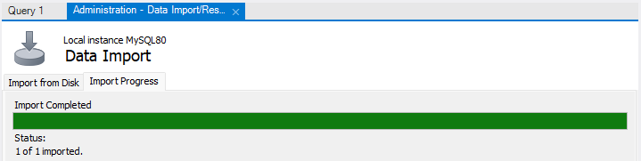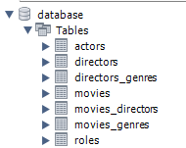

For sql I used sql server management

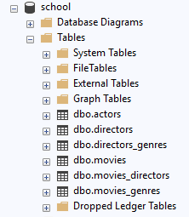 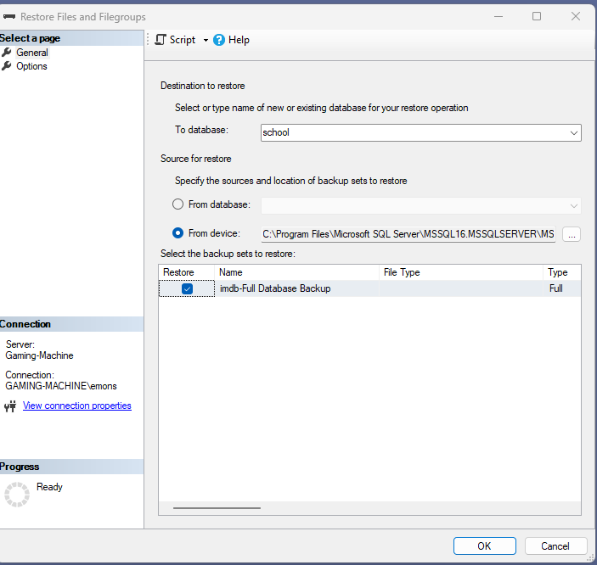

## DB sizes + missing data

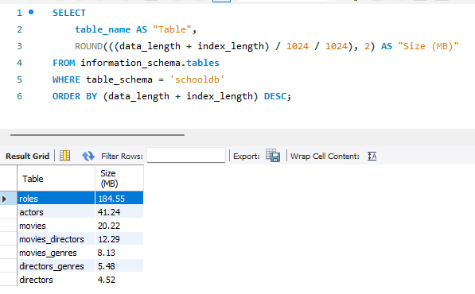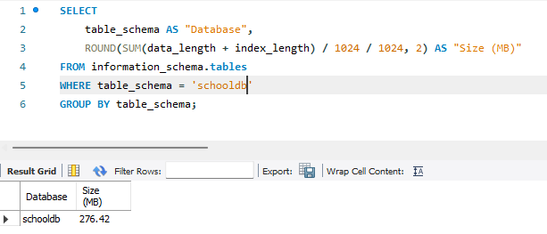

Here you can see the queries that used to get sizes total size is 276.42 mb’s and in the top picute you can see size per table

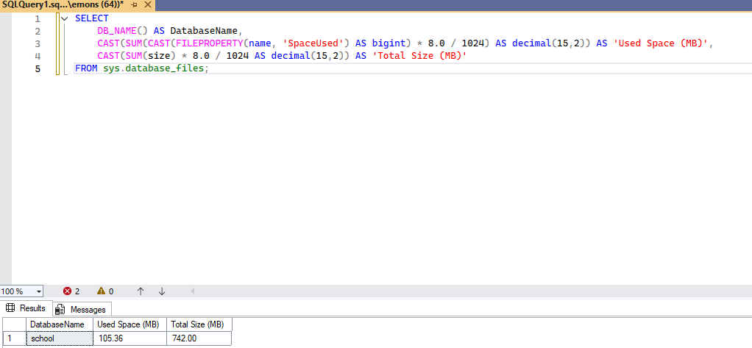

Here querry for sql total size can been seen below

When looking at the db tables I saw that table roles was only there in mysql not sql this was missing

## Migration

First I had to prepare my network to allow access to the DB’s so i set some port forward rules in my router I opened port 3306 for mysql and 1433 for sql



Then I created two rds db’s

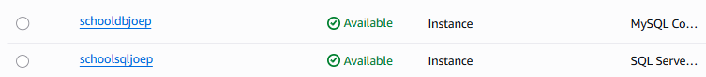

Then I had to create source and target endpoints and check the connection







Also for testing connections and migrating I needed to create a replication instances in the correct vpc



Then I could create the tasks I tried serverless but the connection kept failing and could’t figure out why so I used provisioned and did full load migration all load completed but mysql did have error but looking at the db everything looked fine



My calcuted migration time whit my internet speed was mysql 50 seconds and sql 20 seconds ass you can see it whent slower then expected this is because my calculation where purorly on upload speed but the migration has extra task so I touk longer

## Adding missing table

Now I had to add roles to the sql db I createt a new task and in the table config I put this

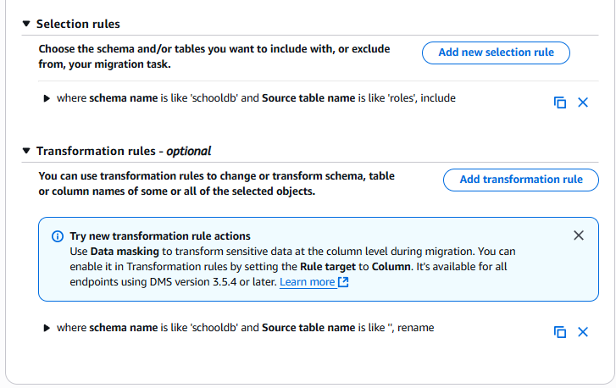

Here you can see that I only want roles from schooldb and I would be renamed because sql has dbo in its naming scheme so bellow you can see before and after

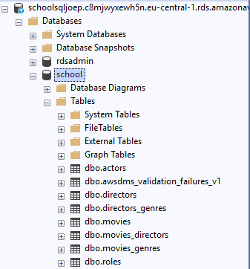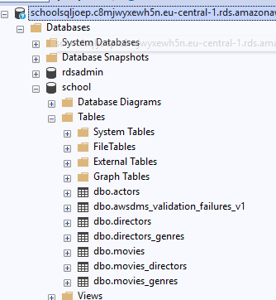



This migration only took 1m 18 seconds afterward I deleted everything and closed the port on my router for security